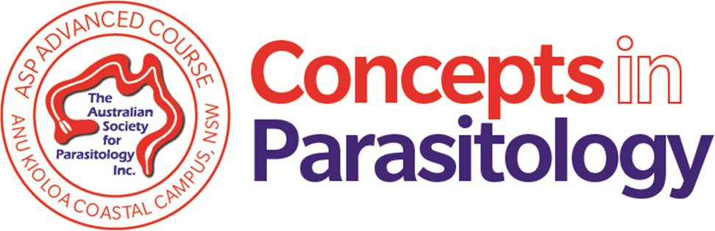
APPLICATION FOR THE ASP ADVANCED COURSE
“CONCEPTS IN PARASITOLOGY”

Application deadline: 10. August 2018
Name, Title and Position of Applicant
Contact Details
Address
Telephone
Email
ASP Membership number
Summary of your Research Experience
Provide an outline of your research experience to date, including a synopsis of your current project [<1000 words].
Statement of Expectations
Outline your expectations for the ‘Concepts in Parasitology’ course, and what you think you would gain by attending [<500 words].
Statement of Goals
Please provide a short description of your goals for the long-term future related to your reasons for wanting to take this course [<100 words].

Supervisor/Research group

REFERENCES
Provide contact details of two people familiar with your academic and research background who could provide the selection committee with an impression of your suitability for the course.
Referee 1
Name
Position
Address
E-mail
Phone
Relationship to applicant
Referee 2
Name
Position
Address
E-mail
Phone
Relationship to applicant
SUPPORTING DOCUMENTATION CHECKLIST
Include a copy of your Curriculum Vitae with this application. Ensure your CV includes a list of all your publications.
Signature
Date

PLEASE RETURN COMPLETED FORM BY EMAIL TO:

A/Prof. Stuart Ralph
COURSE CONVENOR
Department of Biochemistry & Molecular Biology,
Bio21 Molecular Science and Biotechnology Institute
The University of Melbourne, Victoria, 3010 AUSTRALIA

Telephone: +61 3 8344 2284
Email: saralph@unimelb.edu.au

Full course fee: AUD $2,500 (plus GST)
Discounted fee: AUD $1,500 (plus GST) for Members of the Australian Society for Parasitology*
*Applicants must be ASP members at the time of application deadline to qualify for the discount.
Please note: The co-contribution towards the course is payable upon acceptance into the course.

